Electricity bill
1.Problem:
Household bills using multiple consumption slabs, fixed charges, surcharges, rebates.
2.Objectives:
Calculate bill with slabs, compare months, find unusual increase.
3.Assumptios:
Slab 0-100 units Rs.3,101-200 Rs.5 above 200 Rs.7.Fixed charge Rs.50 surcharges 5% if >300 units.
4.Algorithm:
Input units, calculate slab wise ,add fixed ,add surcharge, print bill.
5.Psuedo code:
Read
If units<=100
Bills=units_3
Else if<=200 bill=100-3+(units_300)-5
Else bill=100-3+100-5+(units_200)-7
Add 50
print
6.Test cases:
150 units-600
350 units-2047.5
7.Flow chart:

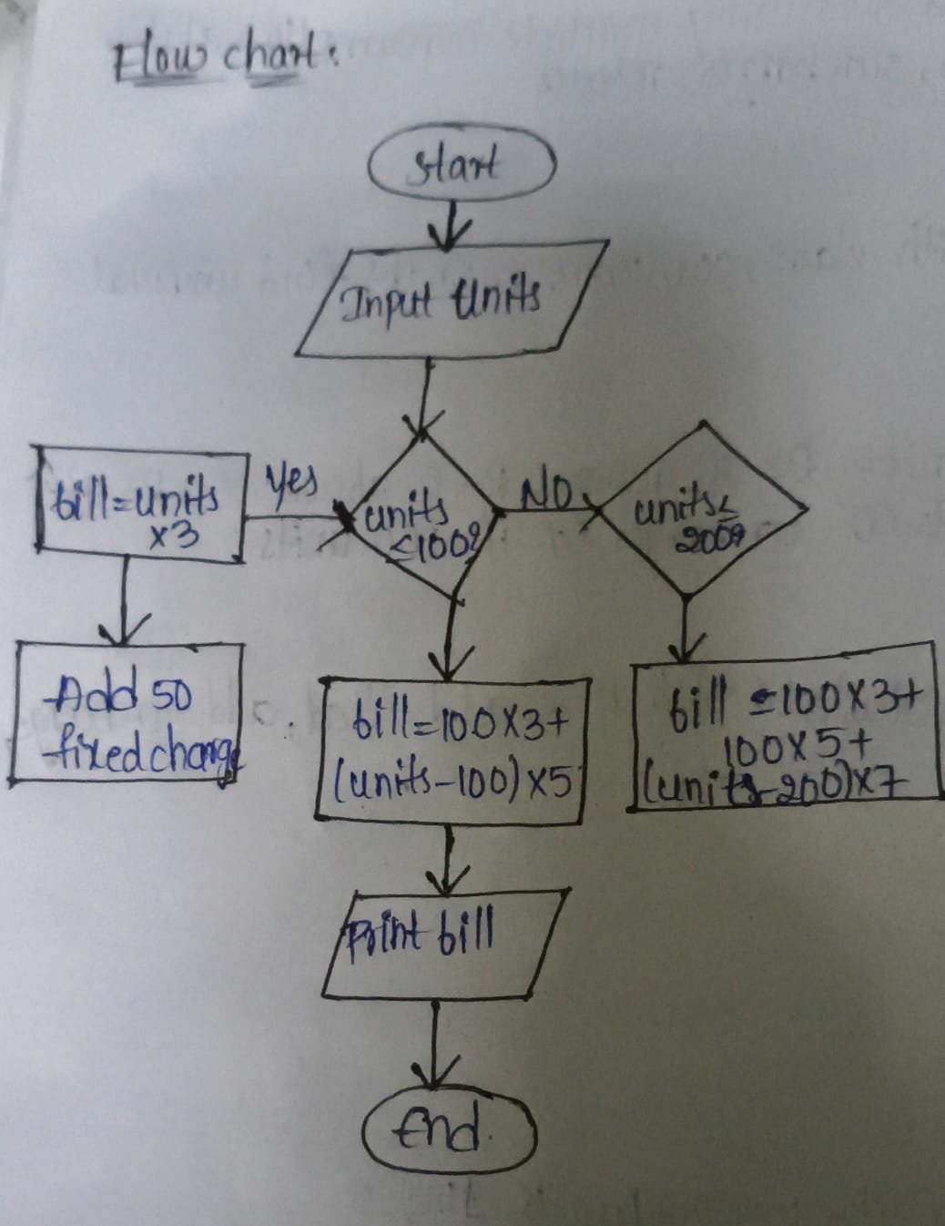
8.code:
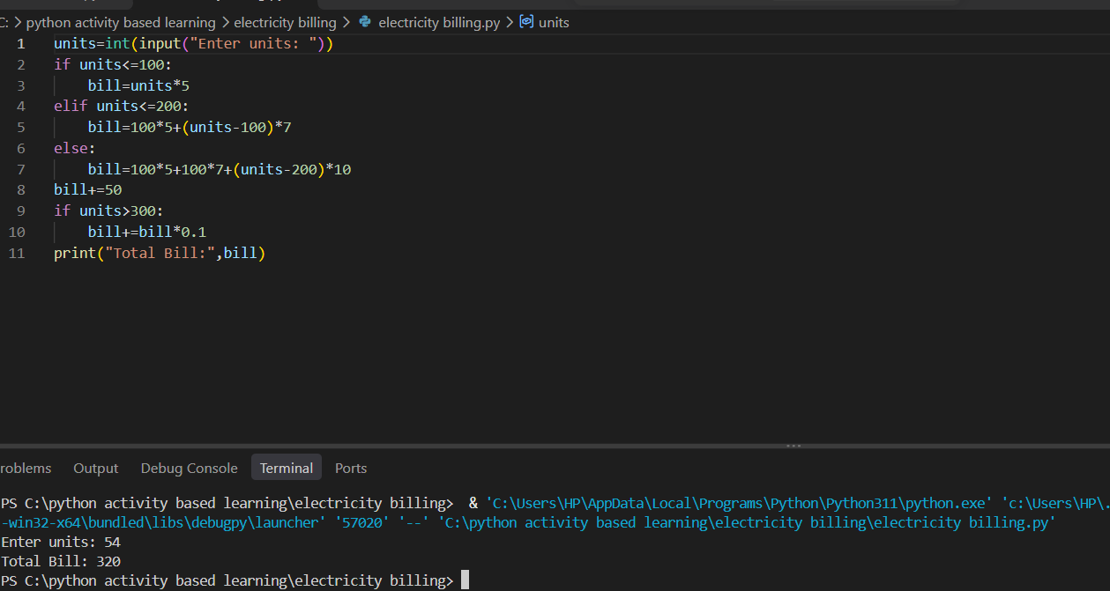
9.Conclusion:
All test cases are passed.

